|  |
| --- |
| **Melon, 1 per 2 SF** |

|  |
| --- |
| **Onions, 16** |

|  |
| --- |
|  |

|  |
| --- |
|  |

|  |
| --- |
|  |

|  |
| --- |
|  |

|  |
| --- |
|  |

|  |
| --- |
|  |

|  |
| --- |
|  |

|  |
| --- |
|  |

|  |
| --- |
|  |

|  |
| --- |
|  |

|  |
| --- |
| **Melon, 1 per 2 SF** |

|  |
| --- |
| **Onions, 16** |

|  |
| --- |
| **Parsley, 4** |

|  |
| --- |
|  |

|  |
| --- |
|  |

|  |
| --- |
|  |

|  |
| --- |
| http://www.foodclipart.com/food_clipart_images/sliced_cantaloup_melon_0071-0806-2512-5852_SMU.jpg |

|  |
| --- |
| **Onions, 16** |

|  |
| --- |
| **Parsley, 4** |

|  |
| --- |
|  |

|  |
| --- |
|  |

|  |
| --- |
|  |



**Onions, 16**



**Parsley, 4**

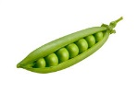

**Peas, 8**

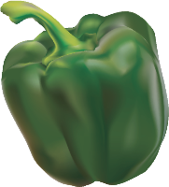

**Pepper, 1**



**Pepper, 1**



**Pepper, 1**



**Pepper, 1**

**Pepper, 1**



**Pepper, 1**



**Pepper, 1**



**Pepper, 1**



**Peas, 8**



**Peas, 8**



**Peas, 8**



**Parsley, 4**